Cloud Speaker Parameter Setting Tool User Manual
- Setting Parameters
- Connect the speaker to the computer via serial port and power it on.
Note：Keep the function key pressed during startup.
- Open the parameter tool YM_ParamTool_xxx.exe, as shown below:
Example: Find the serial port (COM101 in the figure), click "Get Param List"
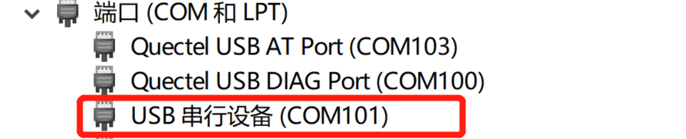
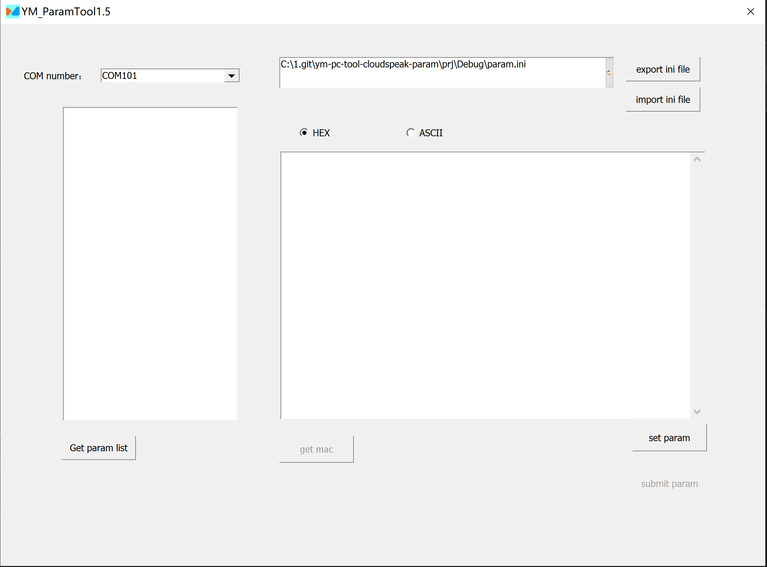
- Double-click "param list" to display a detailed parameter list.
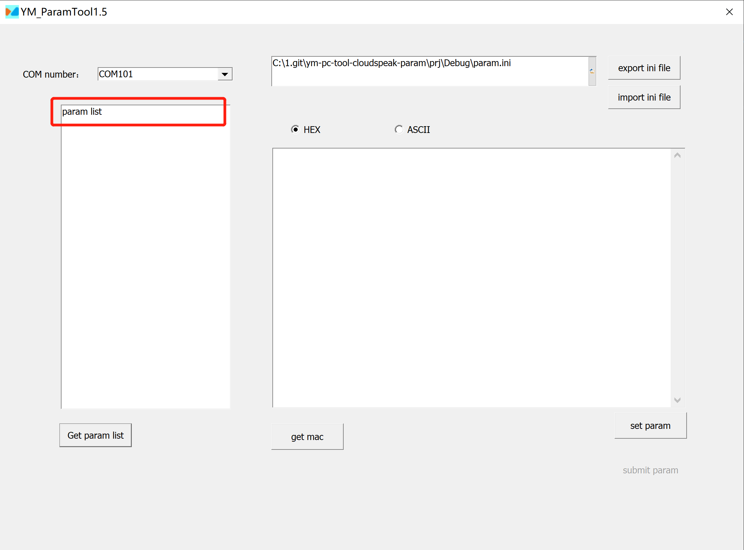
- Select the parameter name that needs to be set, then select the corresponding encoding (HEX or ASCII) in the setting item on the right side of the interface, enter the set value in the input box, and finally click "set Param".
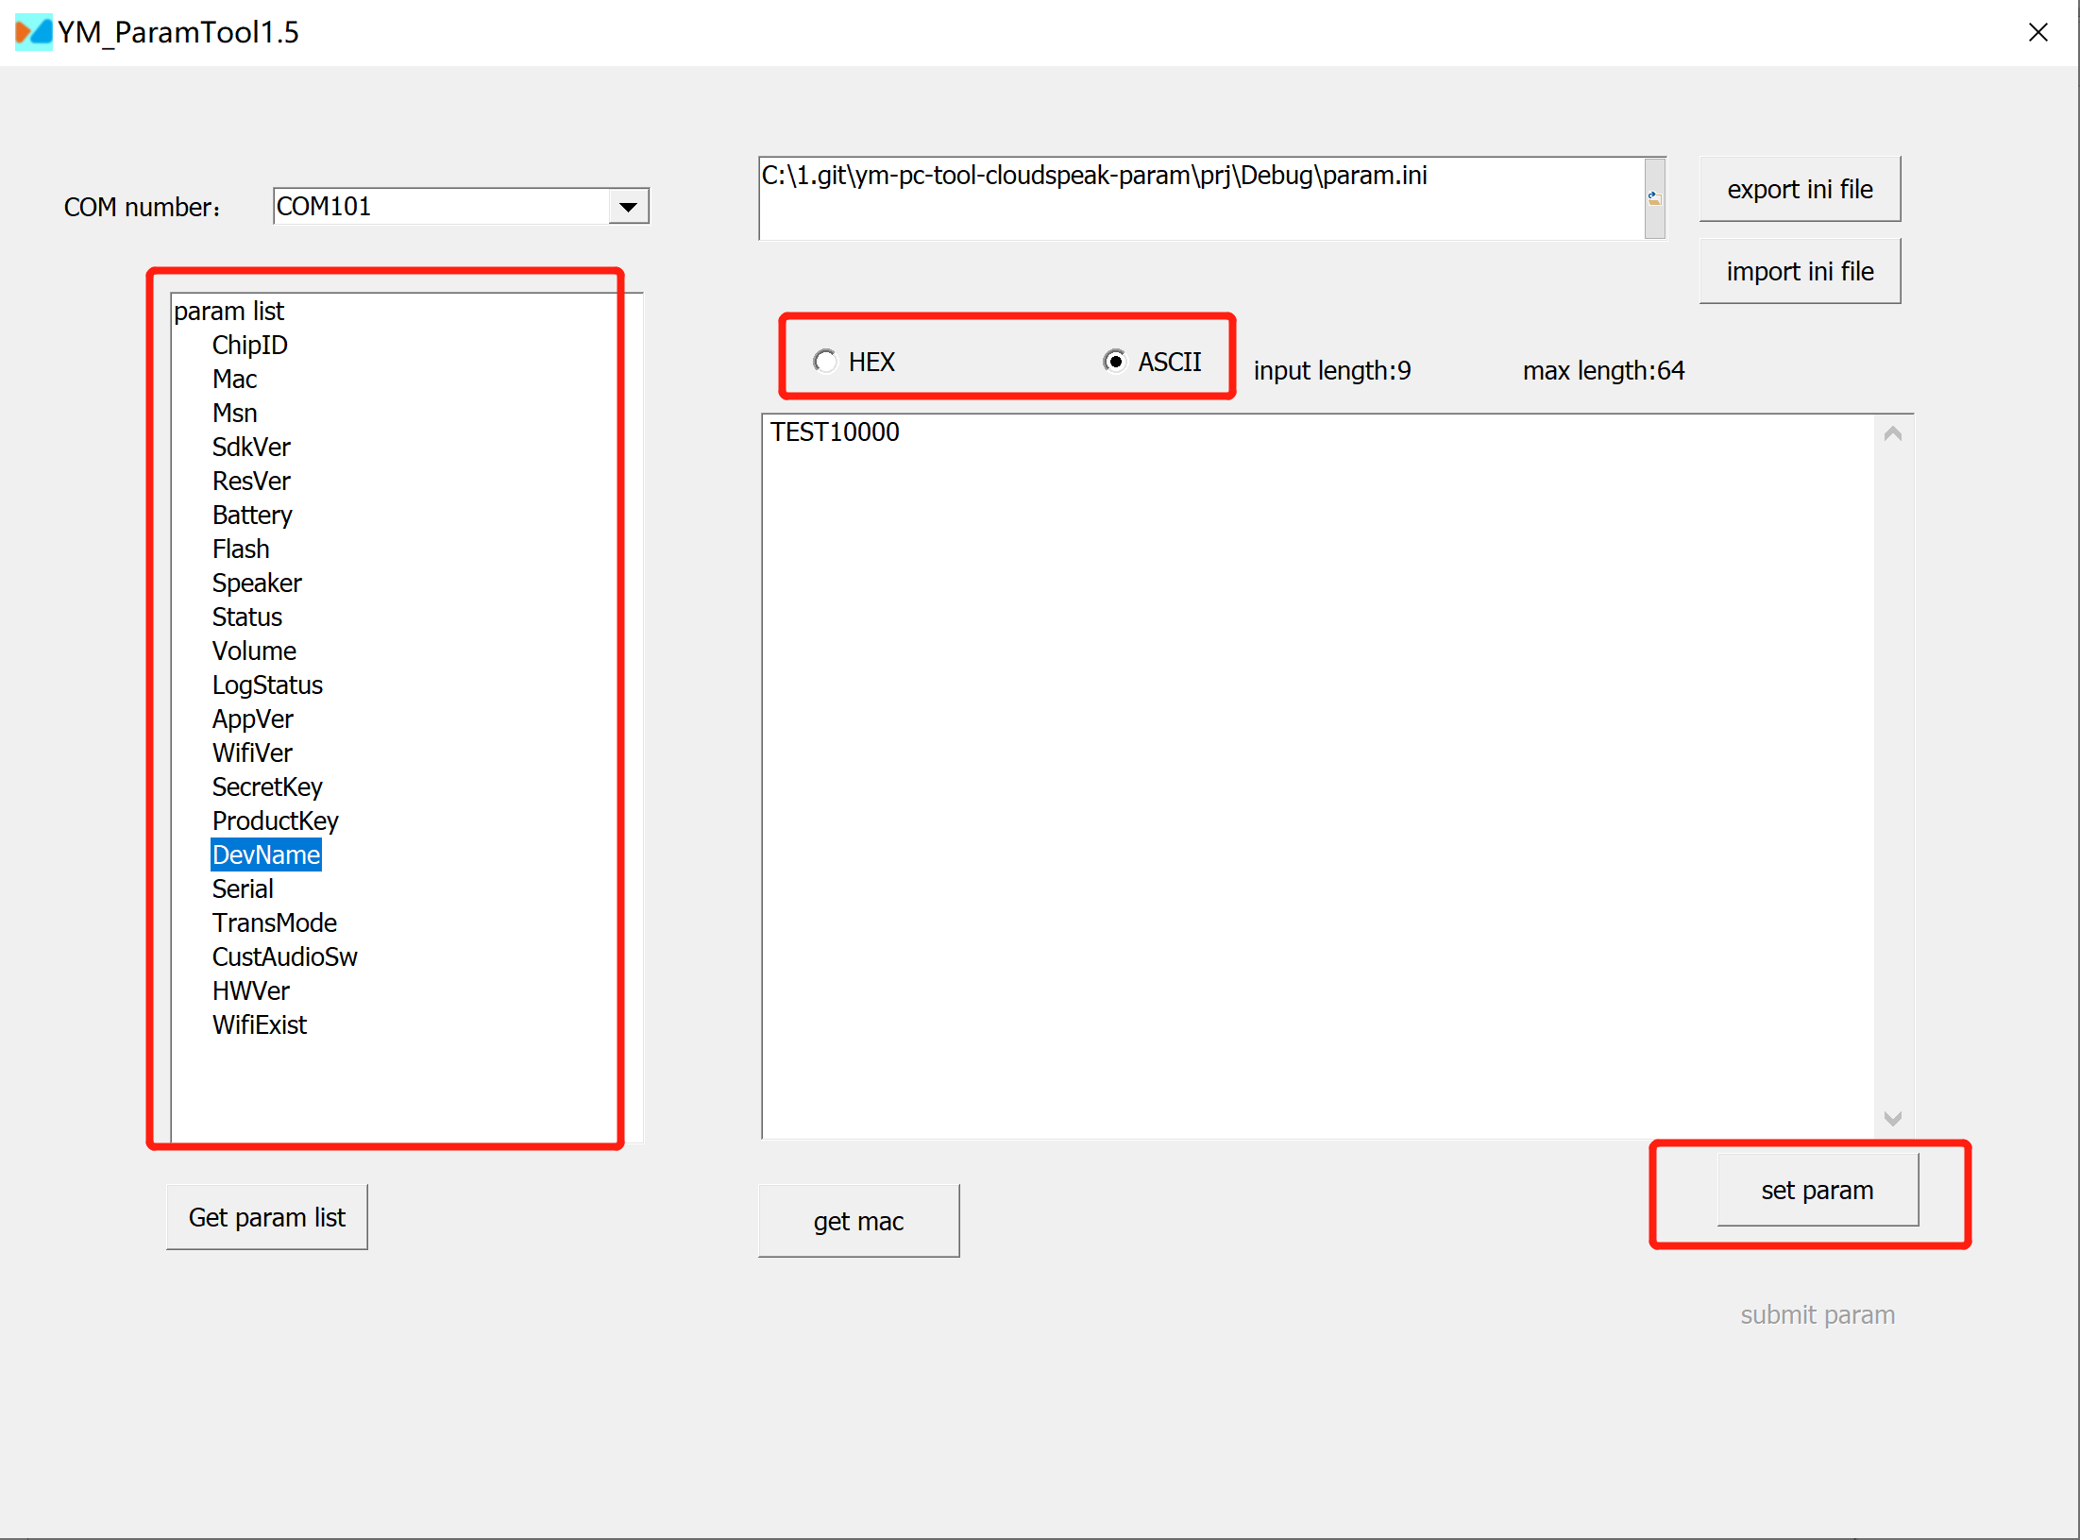
- After setting the parameters, you need to submit and save it, so that the parameter will be written into the machine. Click "commit param".
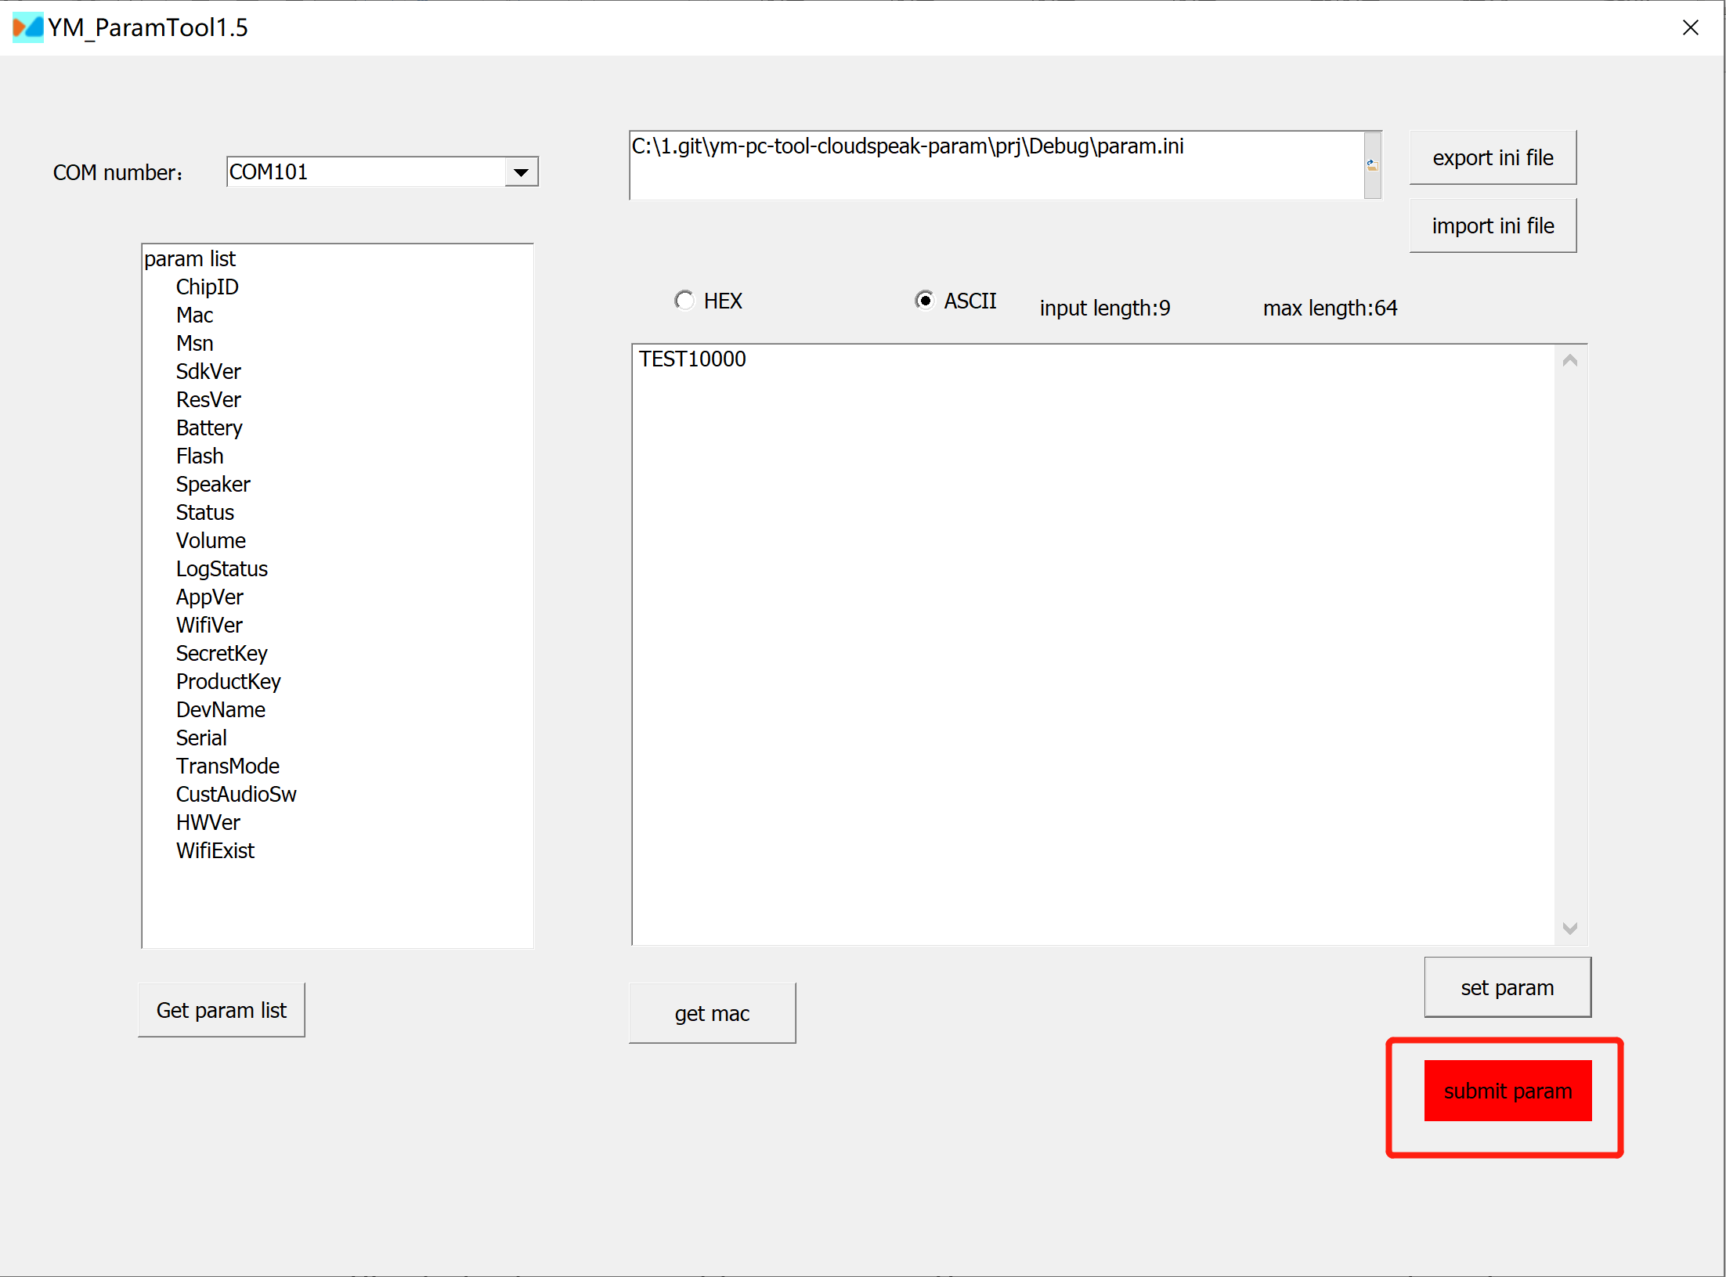
- After committing, a pop-up box will appear indicating that the commission is complete, as shown below.
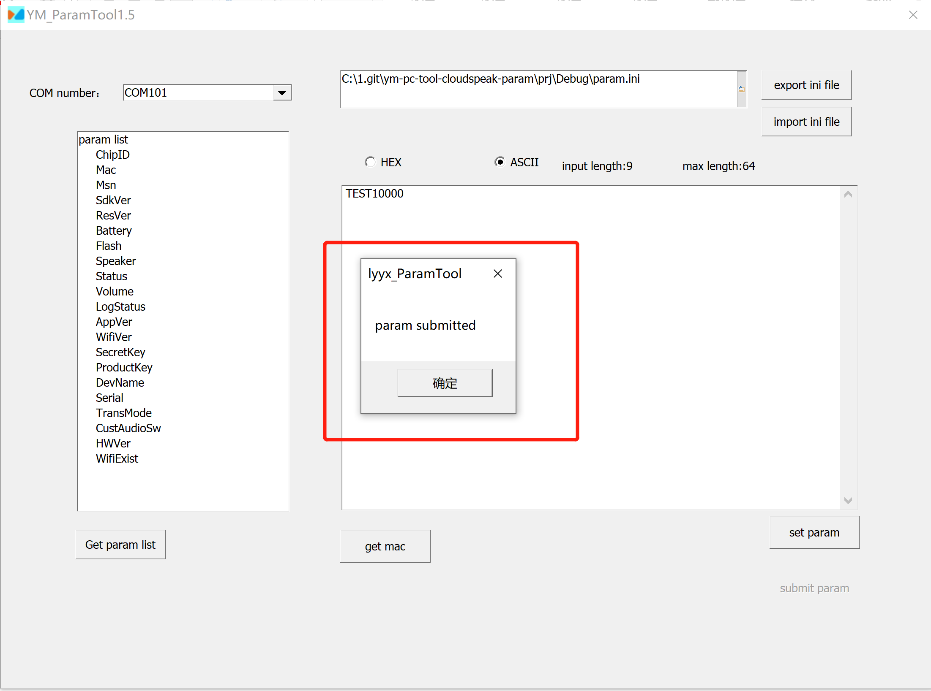

- Importing and Exporting Parameters
- To export parameters: power on the machine, select the serial port, and click "Export ini File". After the export is completed, a prompt " export param done" will appear, as shown below. Then, you will see the exported parameter file, such as param.ini, in the export path.
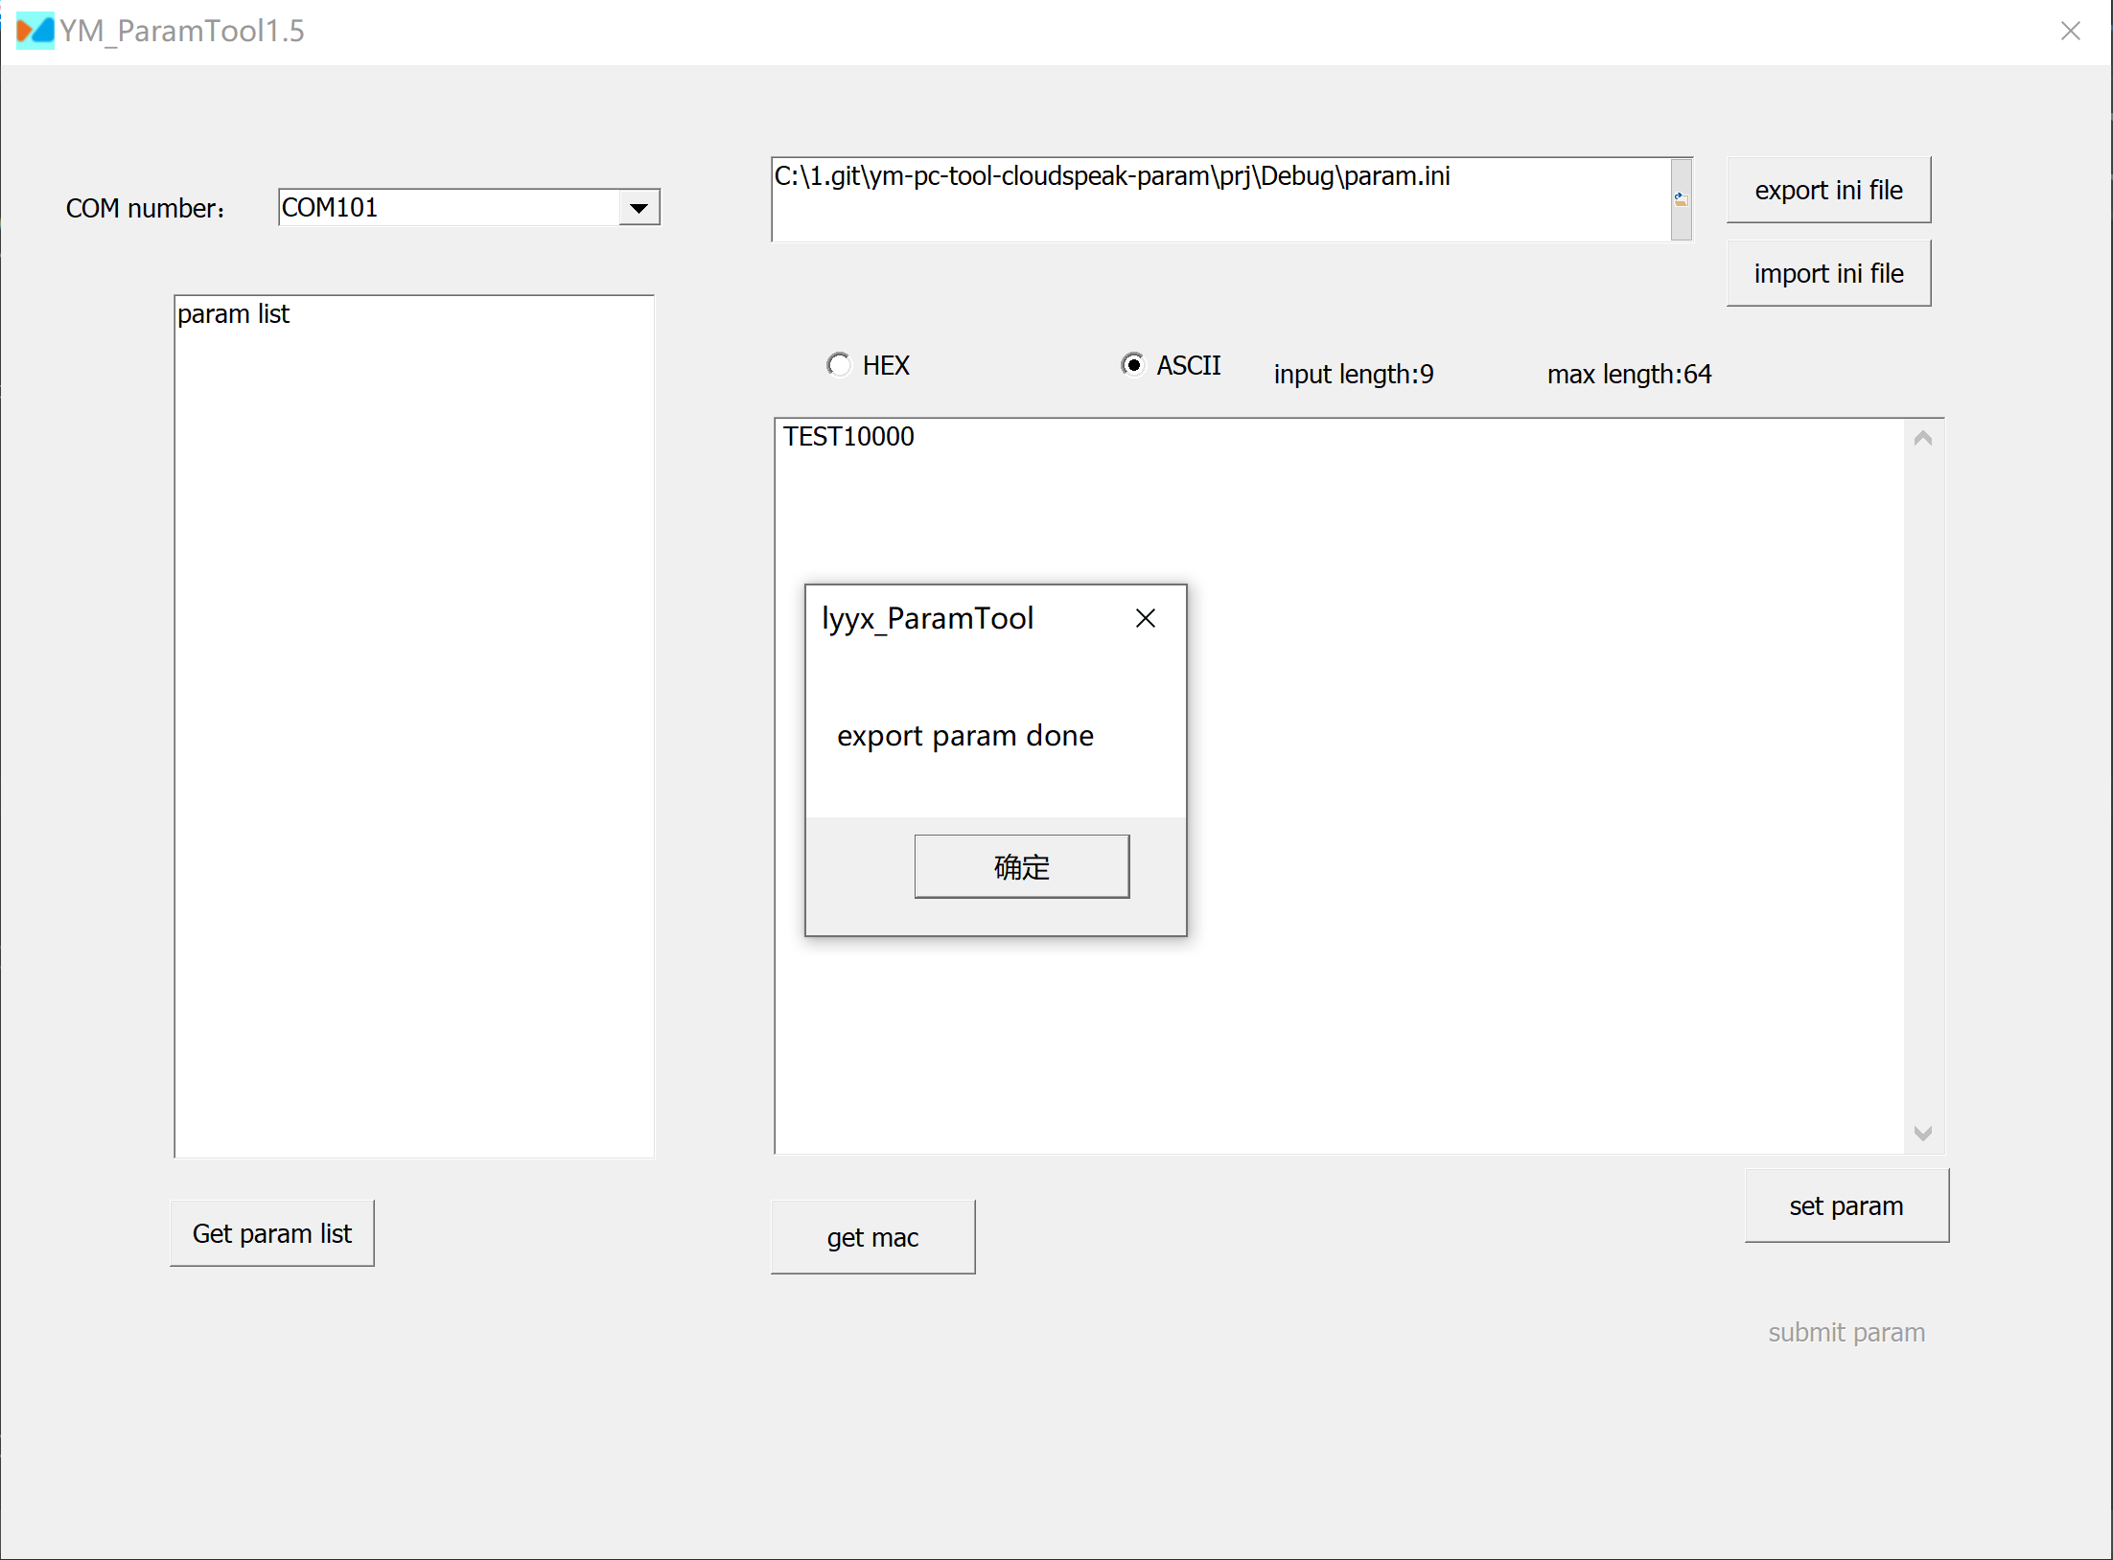
- To Import parameters: Click "Import ini File" to import the parameter file. After successful import, a prompt "Parameter has been submitted" will appear.
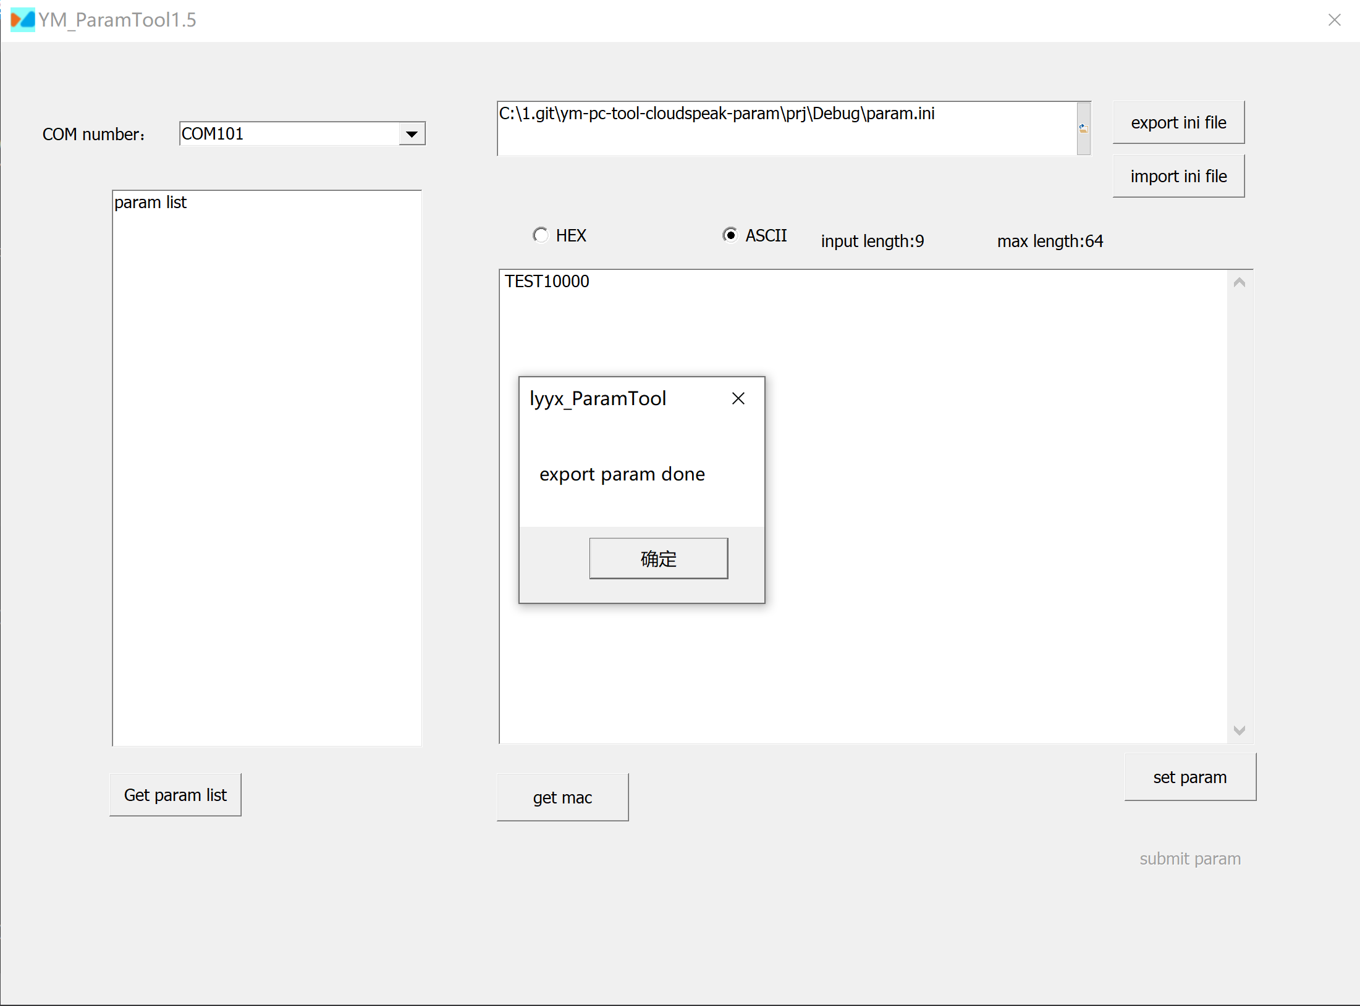
- Param file forma as follows, field name = field value (hexadecimal).
